**Ansh Ranjan**

**ADF Case Study  
Exercise 2: Building Pipelines for Covid-19 Data Ingestion**

**TASK 1: Create an ADF pipeline to copy data**

1. Open your Data Factory and go to Author tab > Pipeline   
   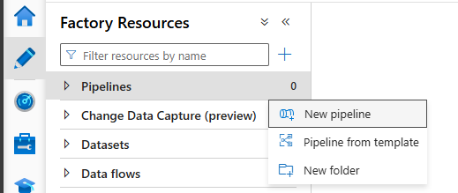
2. Drag a Copy Data activity onto stage
3. Go to source > New Dataset > Azure Blob Storage > Select CSV format   
   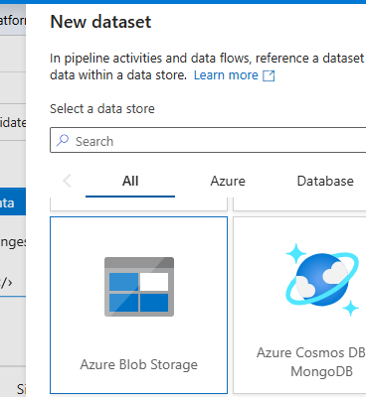
4. Create a new linked service to your storage account. And select your path of csv file   
   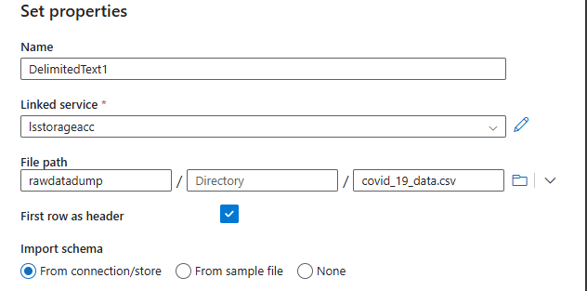
5. In Sink tab, select your destination. Click on New > Azure Gen 2 Data lake   
   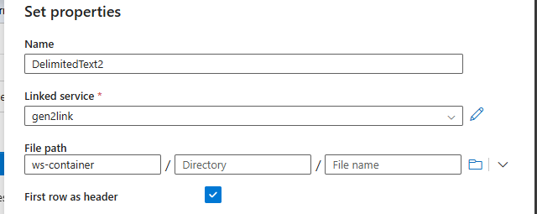
6. Click on Debug button to test your pipeline   
   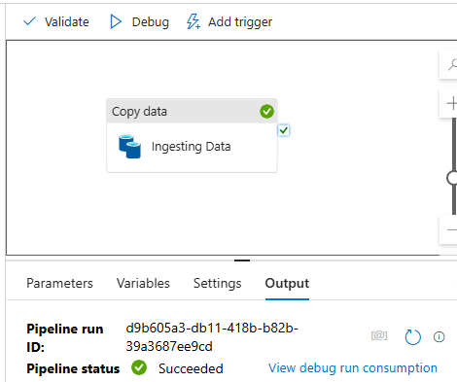

**TASK 2: Configure pipeline triggers for scheduled runs.**

1. Click on Trigger > New/Edit > New > select type as Tumbling Runs > define start dates and reccurance time (going with 24 hrs)   
   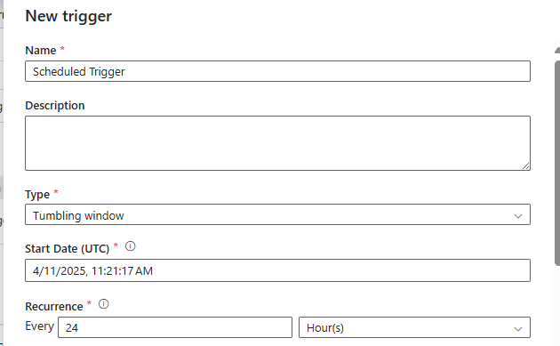
2. Publish your pipelines and Triggers.

**TASK 3: Monitor and troubleshoot the pipeline execution**

1. Trigger your pipeline once for execution. You can view the execution in Monitor tab   
   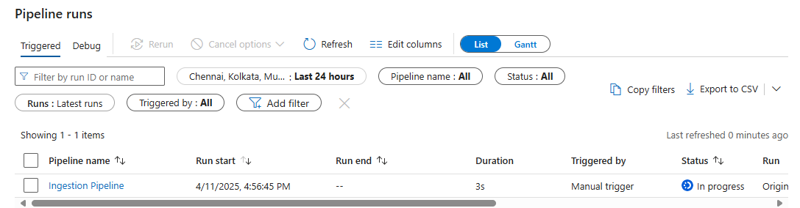

The pipeline has successfully executed   
